1. After cloning the application, run the application (set the startup project to DocumentAnalyzer.API).

2. A browser will be opened after running application. Copy the localhost URL from browser as shown below -

"https://localhost:44352/"

3. Open Postman application and append the URL with “api/DocumentAnalyzer” and paste it with POST request as given below –

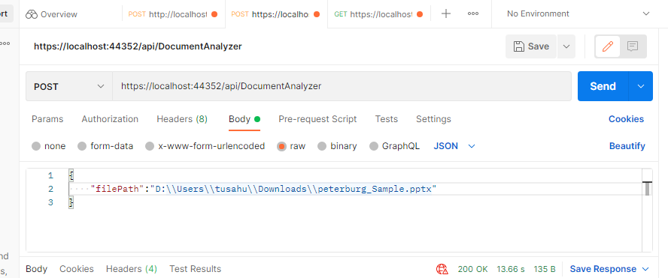

**4. URL will look like below -**

<https://localhost:44352/api/DocumentAnalyzer>

**Parameter – Give the below parameter with document saved in your system. Update the path as per your location of file.**

{

    "filePath":"D:\\Users\\tusahu\\Downloads\\peterburg_Sample.pptx"

}

5. Click on Send button.

The redacted document will be in same path where document is present but with appended with “_edited” name.

Sample documents are in “Sample Document” folder.